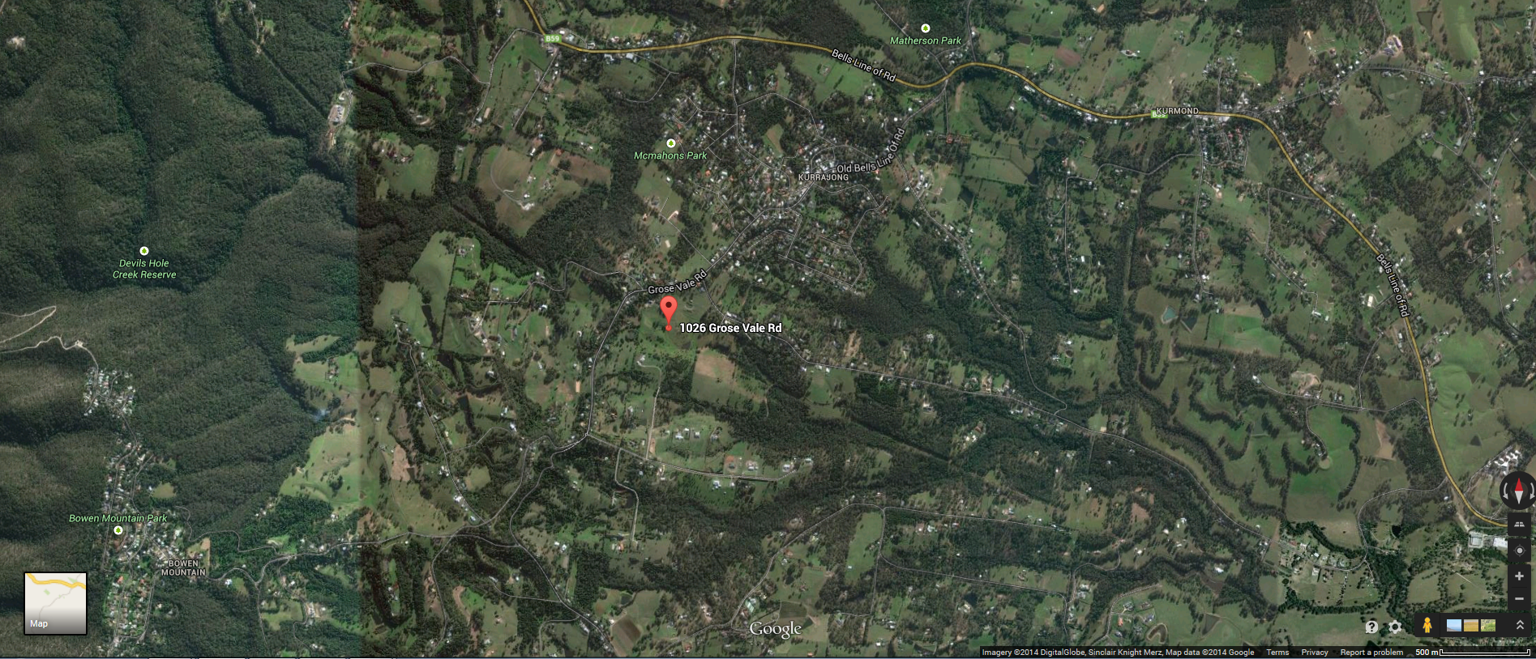

**AERIAL MAP OF 1026 GROSE VALE RD, KURRAJONG**